SEMESTER TWO
Papers written by
Australian Maths Software

YEAR 11

MATHEMATICS SPECIALIST
Units 1 & 2
2016
REVISION ONE

Section One
(Calculator–free)

Name: __________________________________

Teacher: ________________________________

TIME ALLOWED FOR THIS SECTION

Reading time before commencing work: 5 minutes
Working time for section: 50 minutes

MATERIAL REQUIRED / RECOMMENDED FOR THIS SECTION

To be provided by the candidate
Standard items: pens, pencils, pencil sharpener, highlighter, eraser, ruler.

IMPORTANT NOTE TO CANDIDATES
No other items may be taken into the examination room. It is your responsibility to ensure that you do not have any unauthorised notes or other items of a non–personal nature in the examination room. If you have any unauthorised material with you, hand it to the supervisor before reading any further.

To be provided by the supervisor
Question/answer booklet for Section One.
A formula sheet which may also be used for Section Two.
Structure of this examination

 | Number of questions available | Number of questions to be answered | Working time (minutes) | Marks available | Percentage of exam
Section One  Calculator—free | 7 | 7 | 50 | 52 | 35
Section Two  Calculator—assumed | 12 | 12 | 100 | 98 | 65
Total marks |  |  |  | 150

Instructions to candidates

1. The rules for the conduct of this examination are detailed in the Information Handbook.
Sitting this examination implies that you agree to abide by these rules.

2. Write your answer in the Question/Answer booklet.

3. You must be careful to confine your responses to the specific questions asked and to
follow any instructions that are specific to a particular question.

4. Spare pages are provided at the end of this booklet. If you need to use them, indicate
in the original answer space where the answer is continued i.e. give the page number.

5. Show all your working clearly. Your working should be in sufficient detail to allow your
answers to be checked readily and for marks to be awarded for reasoning. Incorrect
answers given without supporting reasoning cannot be allocated any marks. For any
question or part question worth more than two marks, valid working or justification is
required to receive full marks. If you repeat an answer to any question, ensure that you
cancel the answer you do not wish to have marked.

6. It is recommended that you do not use pencil, except in diagrams.

7. The Formula Sheet is not to be handed in with your Question/Answer booklet.

Section One: Calculator–free 52 marks

This section has seven (7) questions. Attempt all questions.
Working time: 50 minutes

Question 1 (7 marks)

(a) Consider the graph of two intersecting lines below.

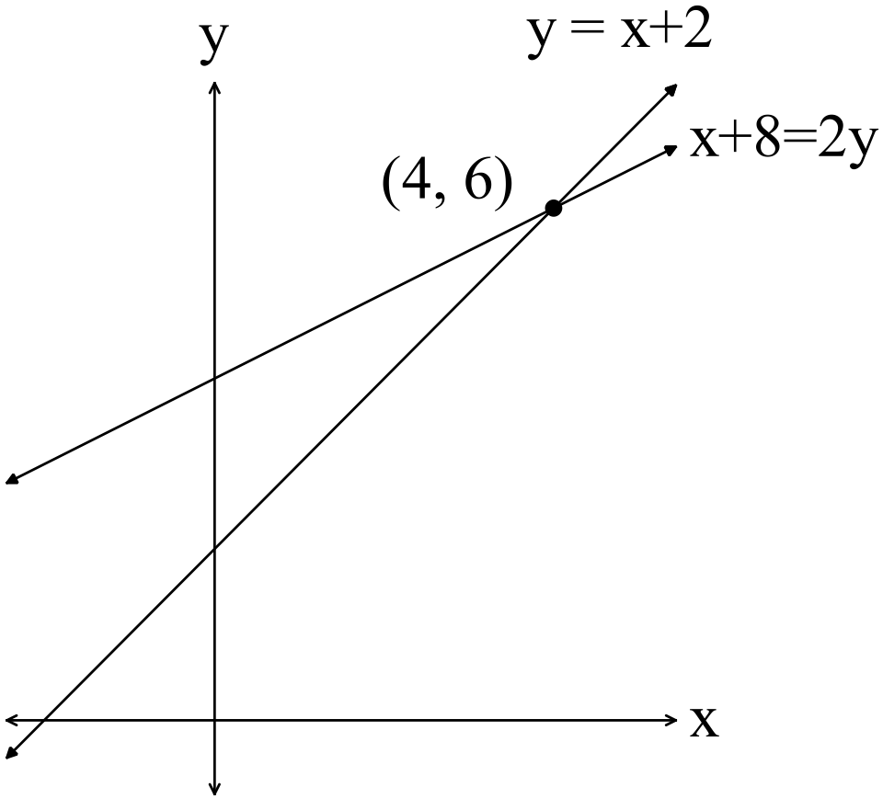

Verify the solution using a matrix method. (4)

(b) Given 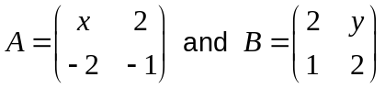, determine 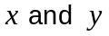if 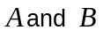are
commutative under multiplication. (3)

Question 2 (6 marks)

(a) Consider the diagram below.
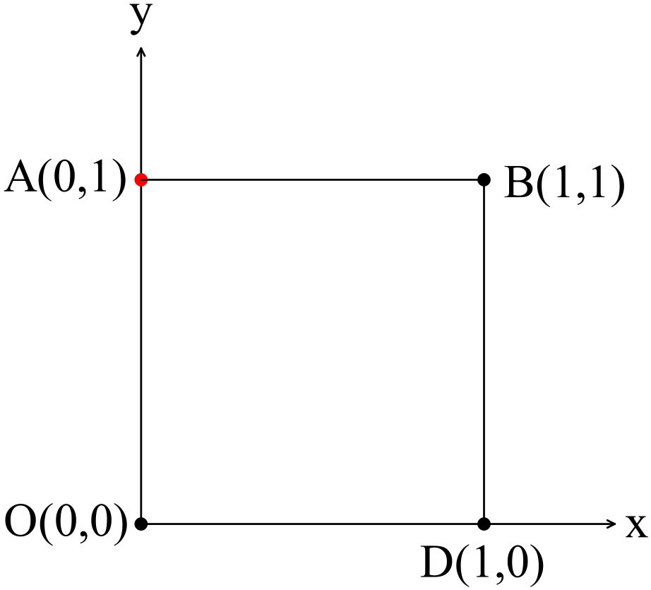
Let 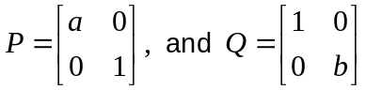 where 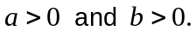

(a) Describe what happens to a point 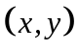 when it is transformed using
(i) matrix . (2)

(ii) matrix . (2)

(b) Write down the matrix required to transform the square ABCD above into the rectangle graphed below. (2)
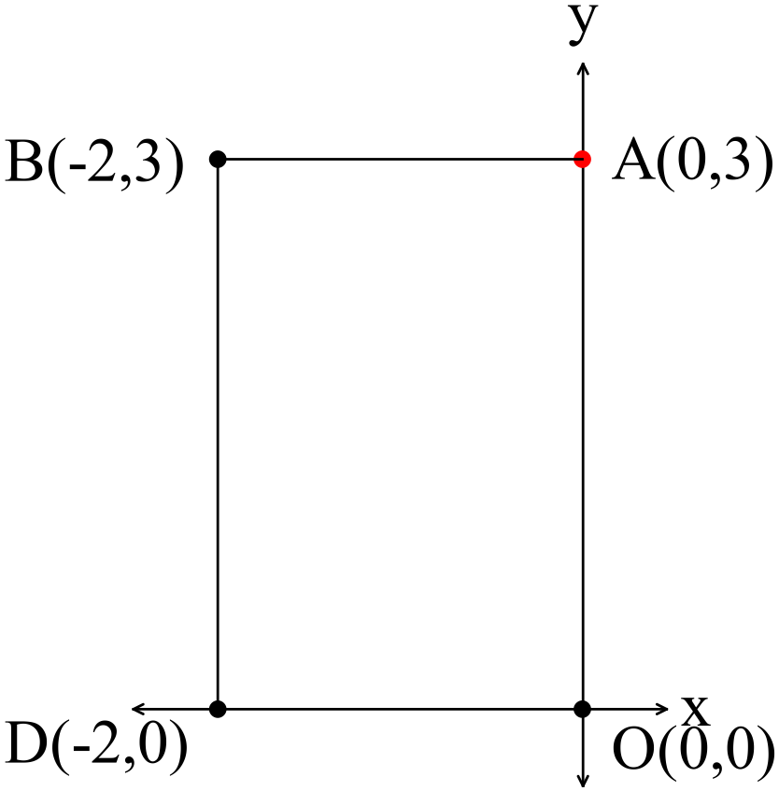
Question 3 (4 marks)

(a) Sketch the function 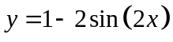 on the domain 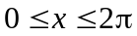. (2)
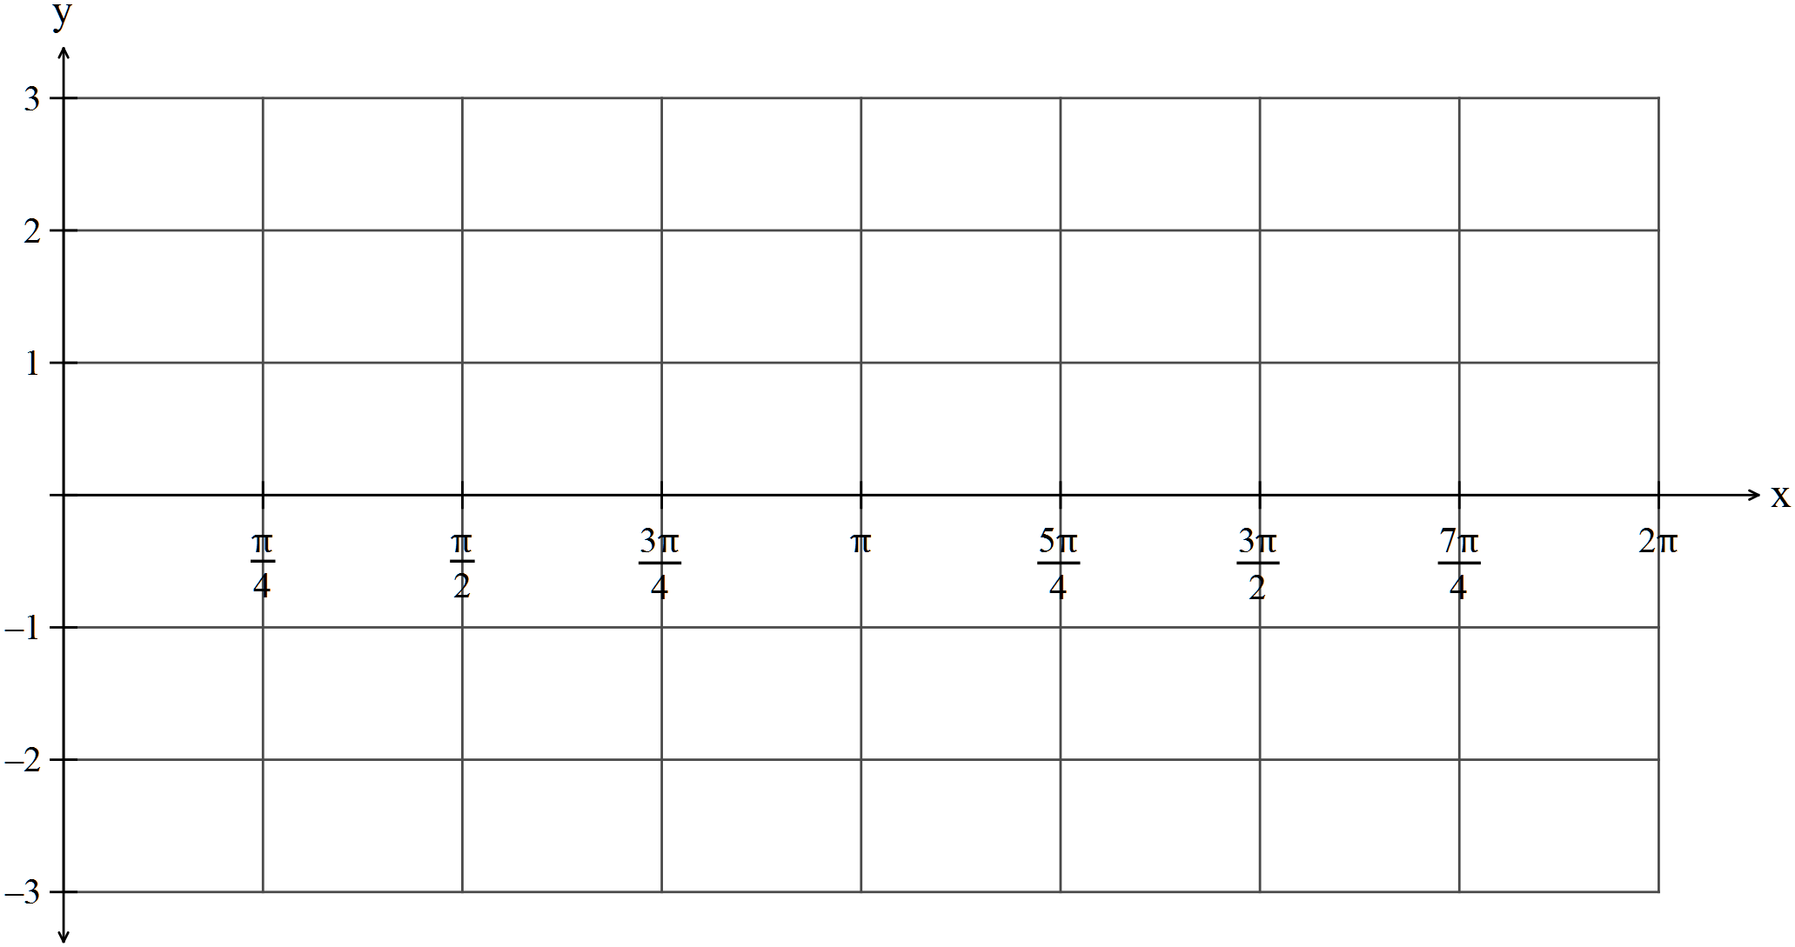

(b) Sketch the function 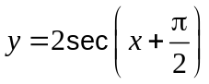on the domain 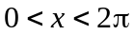 (2)
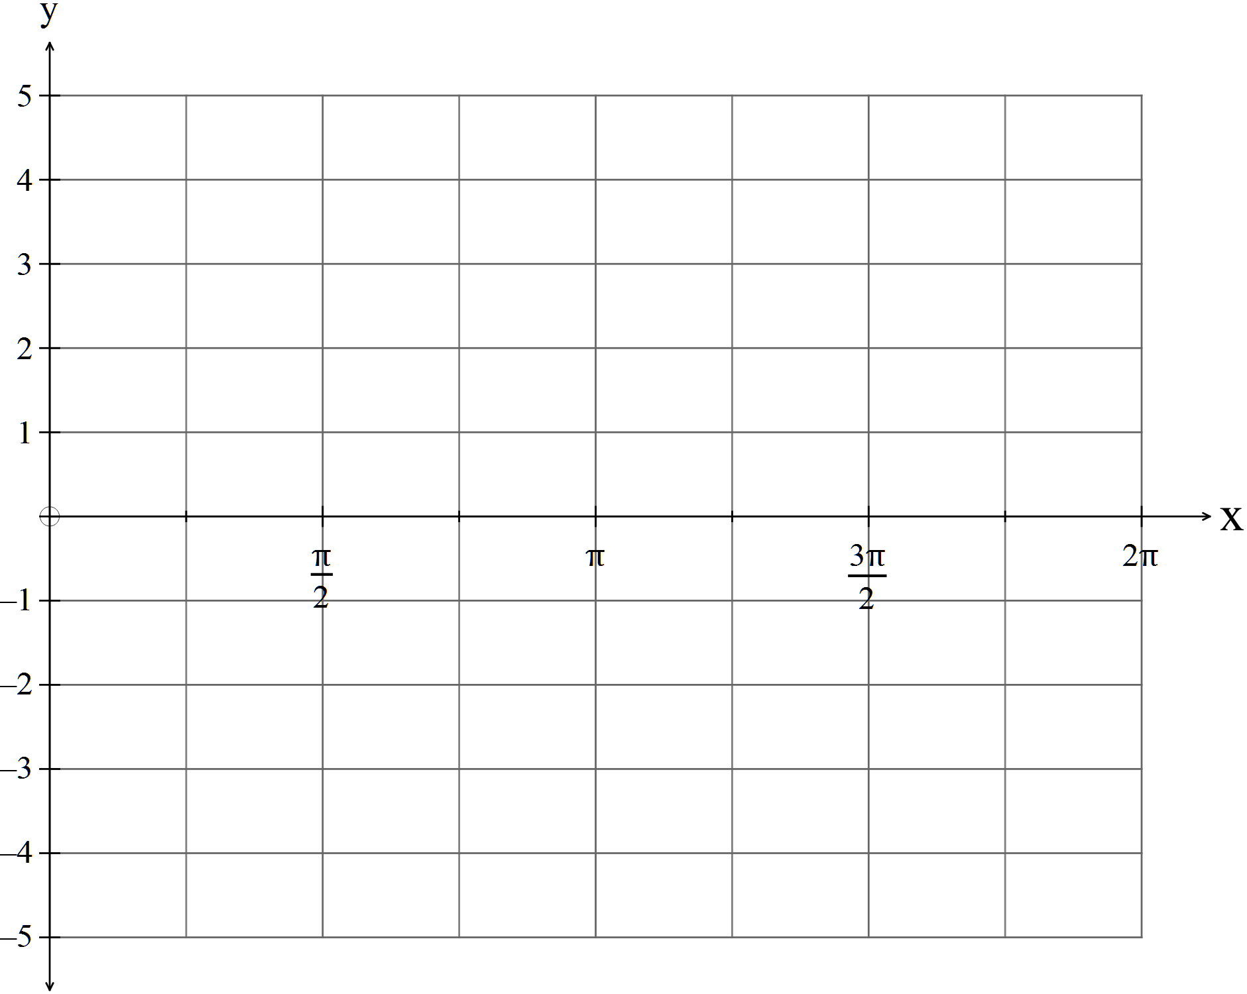
Question 4 (8 marks)

(a) Consider the following diagram.

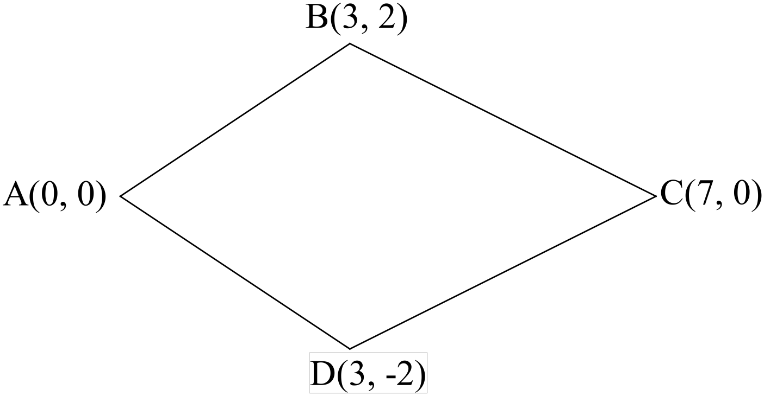

(i) Use vectors to prove that  is not a parallelogram. (1)

(ii) Use the diagonal vectors to prove that is a kite. (4)

(b) Given A(1,1) and 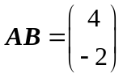 find point P such that 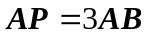. (1)

(c) Find 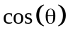 given is the angle between vectors 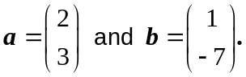 (2)

Question 5 (11 marks)

Two complex numbers shown on the set of axes below

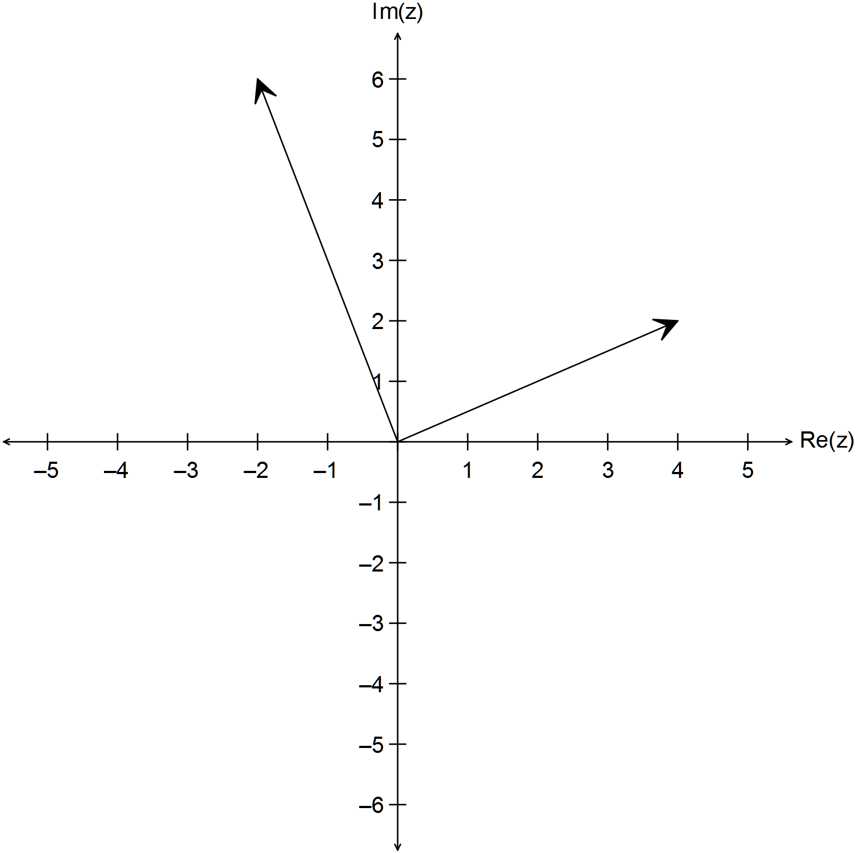
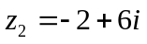
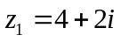

(a) Sketch on the diagram above
(i) 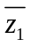 (2)

(ii) 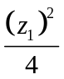 (2)
(b) Determine the expressions for
(i) 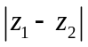 (3)

(ii) 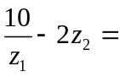 (3)

(iii) 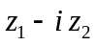 (1)

Question 6 (9 marks)

(a) State the converse of the following theorem. (1)

“The opposite angles of a cyclic quadrilateral are supplementary.”

(b) Prove that “The tangents drawn to a circle from an external point are equal.” (4)

(c) Prove the following using vectors:
“If the midpoints of the adjacent sides of a quadrilateral are joined,
then the resulting quadrilateral is a parallelogram.” (4)

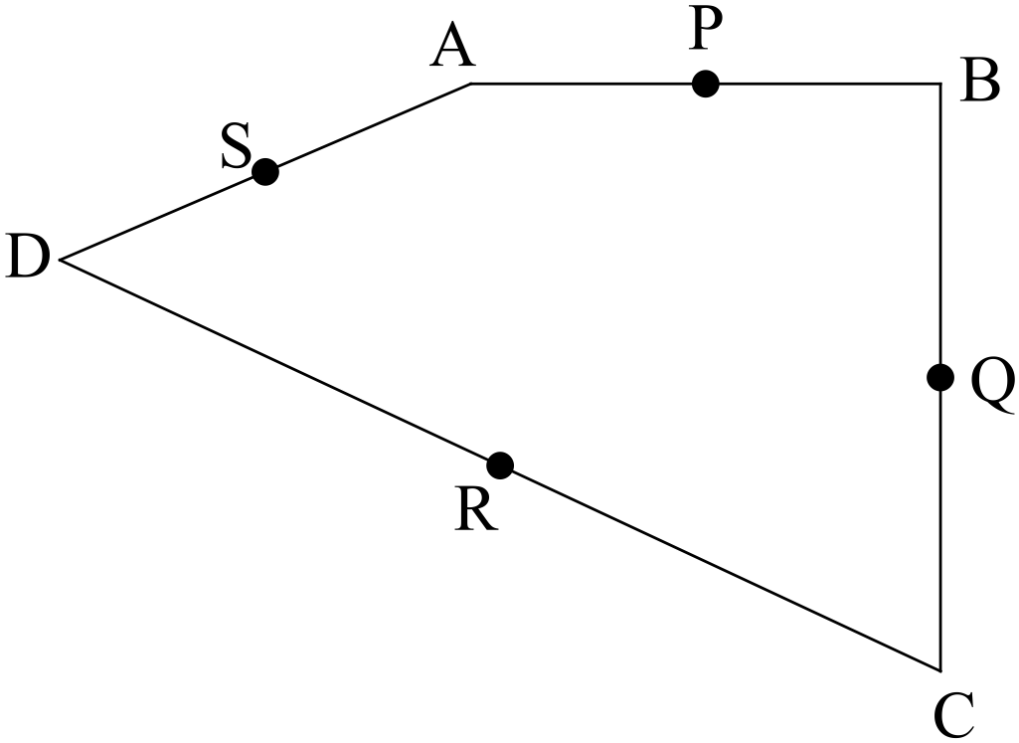

Question 7 (7 marks)
(a) Use the expansion of 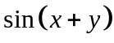 to find an expression for 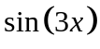. (3)

(b) Solve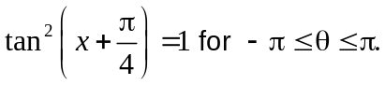 (4)

END OF SECTION ONE

